**Name : Shadril Hassan Shifat**

**ID : 00-30135**

**--------------------------------------------------------------------------------------------------------**

**Sequence Diagram**

1. **Sequence Diagram for Doctors and Patients Appointment**

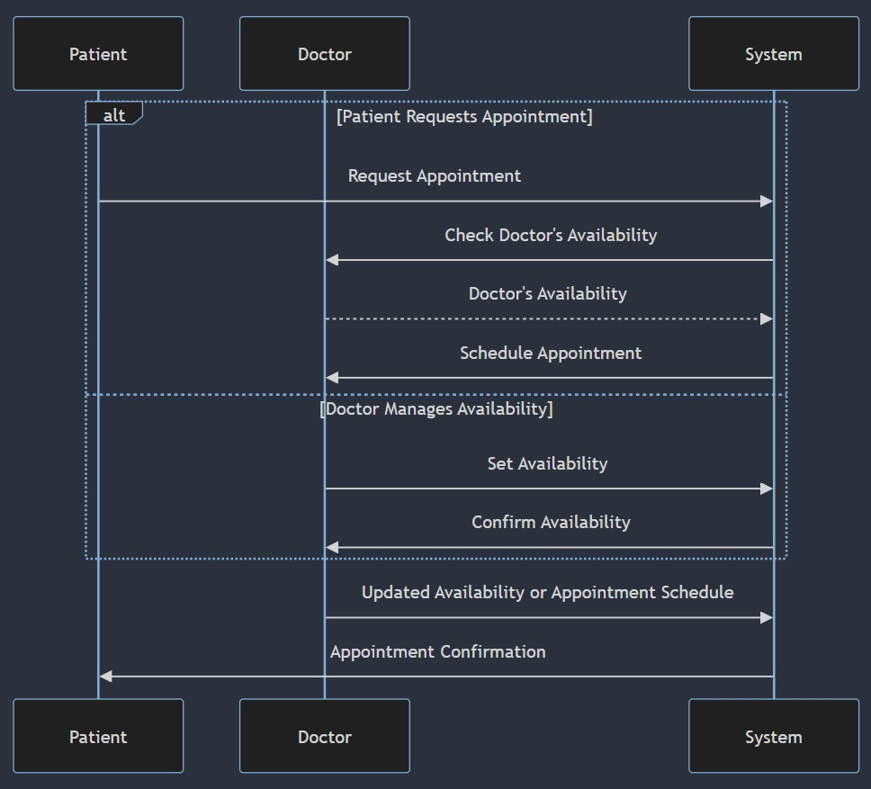

1. **Sequence Diagram for Clinical Decision Support System (CDSS)**

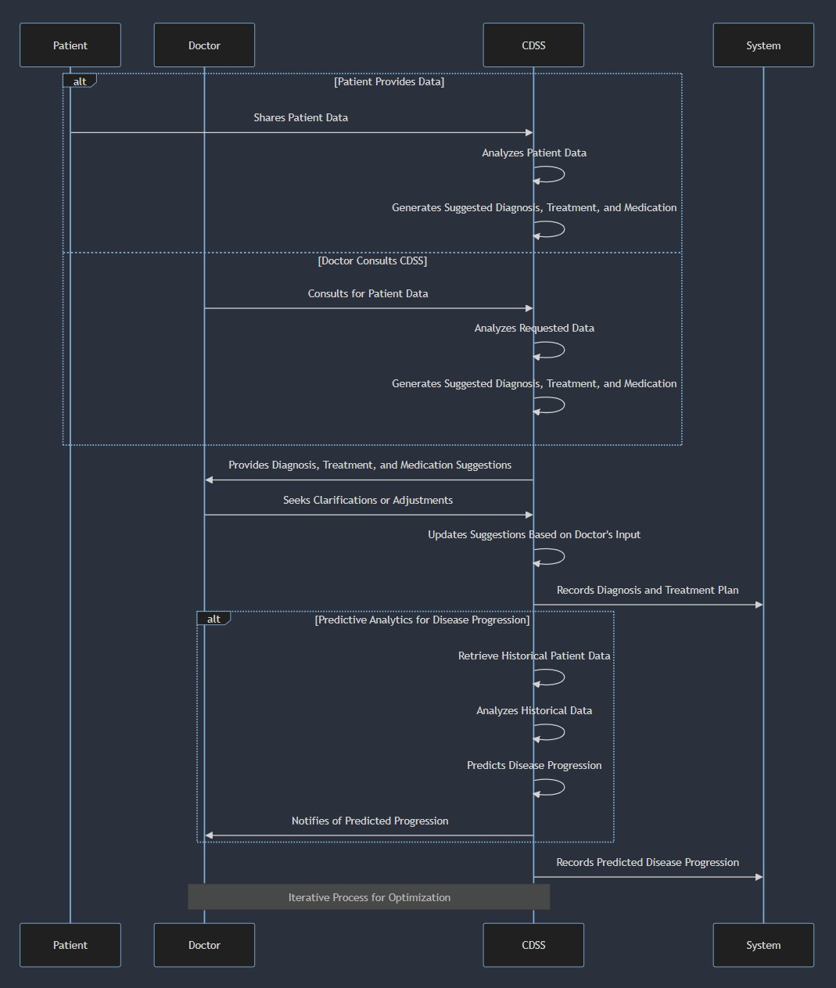

1. **Sequence Diagram for Telemedicine Integration**

